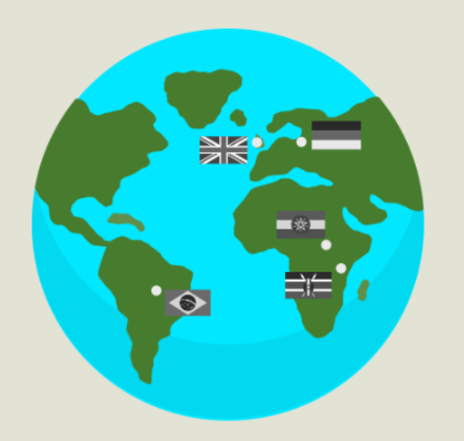
​
​
https://www.taradigm.com/freiburg-europes-solar-city/?srsltid=AfmBOorpit3HebrOuU1IVoYrAJzJx9_GIEgB3seEIY0_uGNQnLxHP2js​
https://usa.streetsblog.org/2024/10/17/curitiba-50-years-of-lessons-from-the-worlds-first-bus-rapid-transit​
https://www.socioeco.org/bdf_fiche-document-1724_en.html​
https://www.worldbank.org/content/dam/Worldbank/document/Climate/Climate-Finance-Projects-briefs/Ethiopia-Humbo-Reforestation.pdf​
https://ltwp.co.ke/​
​
​

